Course Project: Milestone 5
Robert J. Reichhard
DSC 630: Predictive Analytics
Dr. Brett Werner
June 2, 2022

Diabetes Prediction
Introduction
According to the American Diabetes Association, diabetes is a condition in which the body does not produce insulin or cannot utilize insulin properly. Type 2 diabetes is the most common form, but there is also Type 1 and Gestational Diabetes. High blood glucose, elevated blood pressure, and elevated cholesterol levels associated with Diabetes can lead to damage to heart, eyes, teeth/gums, feet, skin, kidneys, and circulatory system (American Diabetes Association, 2019).
I am a Type 2 diabetic, both of my parents are Type 2 diabetics, as well as three of my four grandparents dealt with Type 2 diabetes. Selfishly this project strikes a chord with me personally and I wanted to explore more into the data. More than 1 in every 10 adults have diabetes as well as 25% of adults over the age of sixty-five (Lutz et al., 2009). The complications for diabetes can be quite severe, but for a vast majority of diabetics, it can be avoided.
Since diabetes is a widespread health issue around the globe, many different people would be interested in using Predictive Analytics to determine who may be more on-track to be diabetic than others. Doctors, nurse practitioners, health educators, anyone in the medical industry would likely be interested in predicting diabetes diagnoses. In addition, since diabetes is an issue for so many, people with no medical background or education may be interested in preventing diabetes for themselves or their loved ones.
Dataset
The dataset for this project was obtained from the University of California Irvine Machine Learning Repository at https://archive-beta.ics.uci.edu/. The data is a compilation of five hundred and twenty patients along with fifteen independent attributes for each record. The final attribute is labeled as “class” and indicates either positive or negative for diabetes. The patient age attribute is numerical and loaded as an integer. The remaining attributes are binary. The entries are either yes indicating the attribute is present or no indicating the attribute is not present. These attributes are gender, polyuria, polydipsia, sudden weight loss, weakness, polyphagia, genital thrush, visual blurring, itching, irritability, delayed healing, partial paresis, muscle stiffness, alopecia, and obesity. These attributes are important as they may indicate who in the future may be diagnosed with diabetes. The American Diabetes Association website has a risk assessment that inquires about some of the attributes listed above including age, gender, family history, blood pressure, physical activity level, and race among other things (American Diabetes Association, 2019).
One risk in this project I was concerned about initially was using data that has imbalanced classes. If one of the classes, either positive or negative, is represented too much then it may train the model incorrectly to expect that same balance in future predictions. After exploring the data I decided this dataset should be acceptable and the contingency plans will not be necessary. The Diabetes dataset has sixteen independent variables with one dependent variable, the class (positive or negative for Type 2 Diabetes). That dependent variable is somewhat well-balanced with 64% of the records being positive. The sample size of 520 records should also not be a concern either.
Fifteen of the sixteen independent variables are binary with either a yes or no for the attribute being present in the record. One of the variables, age, is a numerical variable of age in whole numbers. While there are certainly some outliers, the age variable does appear to have a distribution close to normal. See visualization below:
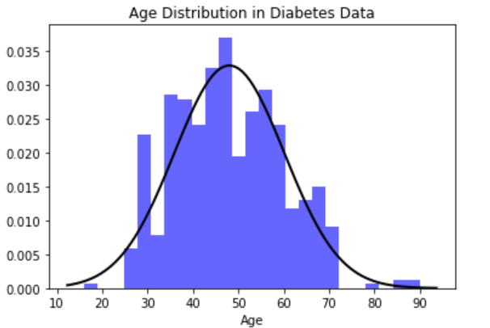
Project Considerations
The intended result of this project is to have a model generated that will be able to predict whether patients will be diagnosed with diabetes in the near future with relative accuracy. The dataset already includes a binary class (positive or negative) making this an exercise in supervised learning since the target class is identified. Since the target class is binary, suggested popular algorithms are logistic regression, k-nearest neighbors, decision trees, support vector machine, and naïve bayes (Brownlee, 2020). Going into this course, I feel somewhat more comfortable with logistic regression and k-nearest neighbors.
While those algorithms would get the job done and help me predict diabetes in future patients, I would like to take this opportunity to utilize something I am not familiar with at this time. After reading the YMCA case study in the Applied Predictive Analytics textbook, my first choice is going to be a Decision Tree (Abbott, 2014). Since almost all of the independent variables are binary variables, I believe a Decision Tree would be an accurate algorithm to choose. The main reason I would like to use a Decision Tree is for making the results more easily digestible by stakeholders. Since the attributes are fairly straight forward, being able to point at specific nodes and identify certain combinations of attributes would make the results more palatable. The evaluation method there would then become the receiver operating characteristic as well as a confusion matrix (Leung, 2019). Through this project I am hoping to learn how to utilize imperfect datasets to predict classifications on unknown data using algorithms I am not overly familiar with at this point in my journey.
Next step is to clean the data after exploring it above. For the binary features, I mapped each value to be a 1 for present or ‘yes’ or a 0 for not-present or ‘no’. The gender variable was mapped with 1 for male and 0 for female. Lastly the target was mapped to 1 for positive and 0 for negative. Next the updated dataframe was split into X and y for the features and target and then split into an 75/25 training/testing split.
Decision Tree Results
Here is a visual representation of the resulting Decision Tree:
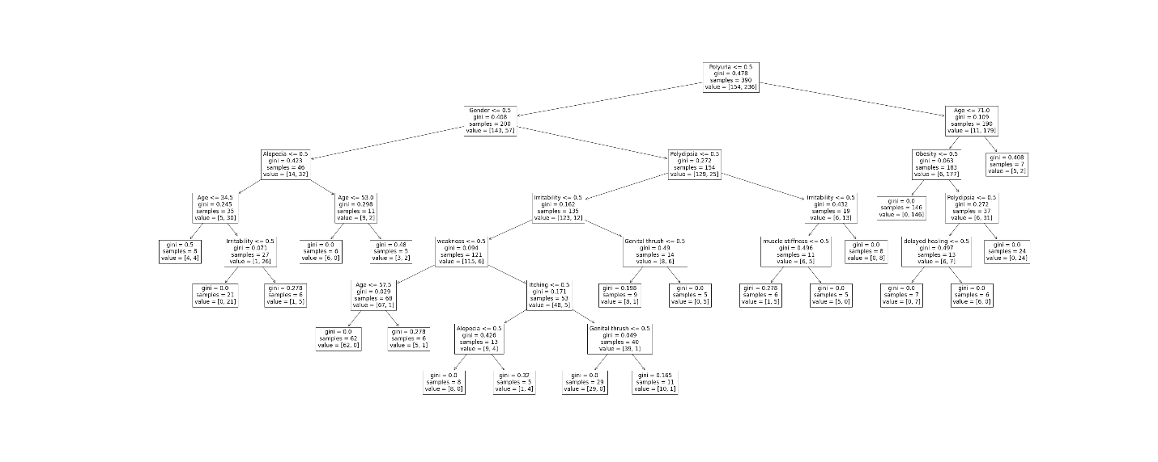
Here is a visual representation of the evaluation metrics:
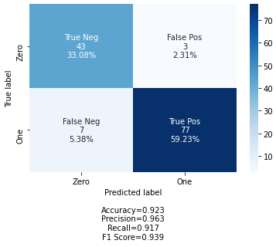
The accuracy of the predictive model is 92.3%, which may be a concern for overfitting. In my research for this model, it was advised that Random Forests can overcome the Decision Tree’s penchant for overfitting. Perhaps that will be another model to attempt. The most important features in the decision tree were Polyuria (excessive/frequent urination) and Gender, followed by Polydipsia (excessive thirst) and Alopecia. I am led to predict that excessive thirst and urination are likely highly correlated (as one leads to the other), but along with gender can be a good predictor of diabetes.
Random Forest Results
After obtaining an accuracy of 92.3% for the Decision Tree, I built a Random Forest Classifier next. One different method of note for this Random Forest was that I started with the default parameters and utilized GridSearchCV to cross validate and find the best parameters to fit the diabetes data. The cross validation found that the best parameters are a maximum depth of 11 splits, 1 feature at a time, and to utilize gini criterion. I trained a second Random Forest Classifier on the training data, but explicitly using the best parameters previously listed. After being tested against the set aside testing features I was shown an accuracy score of 99.23%.
Here is a Confusion Matrix for the Random Forest:
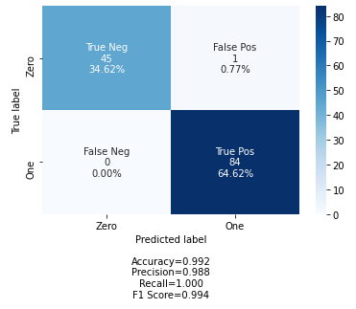
Feature importances:
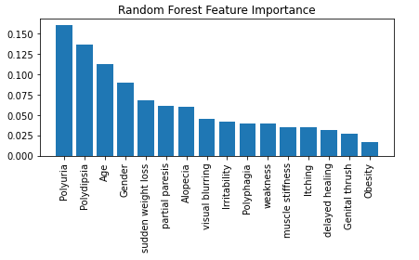
Similar to the Decision Tree, the Random Forest found that polyuria and polydipsia are the most important features for generating a prediction of diabetes accurately. Age and Gender are the next two.
Conclusion
Between the two options attempted, I would feel quite comfortable utilizing the fitted Random Forest Classifier model to predict if a patient is diabetic or not. The model was able to accurately predict all but 1 example from the testing data and that was a False Positive. Considering the subject is a patient’s state of health and how serious diabetes can be, it would be preferable to provide a False Positive over a False Negative. At least with a False Positive, the patient should immediately obtain additional medical direction and testing to determine how to combat the diabetes. However, since it is false it should not have lasting effects. A False Negative would tell a truly diabetic person that they are not diabetic. This could cause many complications and health issues if abnormal blood sugar levels are not treated through a physician’s care.
For future predictions depending on the situation, it may even be worth gathering additional samples. Those samples may also only be the top four most important features (polyuria, polydipsia, age, & gender) if that makes the process smoother. It would be interesting to see an accuracy score and confusion matrix for solely those four features.

References
Abbott, D. (2014). Applied predictive analytics: principles and techniques for the professional data analyst. Wiley.
American Diabetes Association. (2019). Diabetes Overview - Symptoms, Causes, Treatment. Diabetes.org. https://www.diabetes.org/diabetes
Brownlee, J. (2020, April 7). 4 Types of Classification Tasks in Machine Learning. Machine Learning Mastery. https://machinelearningmastery.com/types-of-classification-in-machine-learning/
K, G. M. (2020, August 30). Machine Learning Basics: Support Vector Machine (SVM) Classification. Medium. https://towardsdatascience.com/machine-learning-basics-support-vector-machine-svm-classification-205ecd28a09d
Leung, K. (2019, November 20). How to Code and Evaluate of Decision Trees. The Startup. https://medium.com/swlh/how-to-code-and-evaluate-of-decision-trees-2d94093b3c1a
Lutz, J., Hess-Fischl, A., & Leontis, L. M. (2009, May 26). What Is Type 2 Diabetes? Endocrineweb.com; EW. https://www.endocrineweb.com/conditions/type-2-diabetes
Starmer, J. (2019, September 30). Support Vector Machines Part 1 (of 3): Main Ideas!!! Www.youtube.com. https://www.youtube.com/watch?v=efR1C6CvhmE
UCI Machine Learning Repository. (2022). Uci.edu. https://archive-beta.ics.uci.edu/ml/datasets/early+stage+diabetes+risk+prediction+dataset

